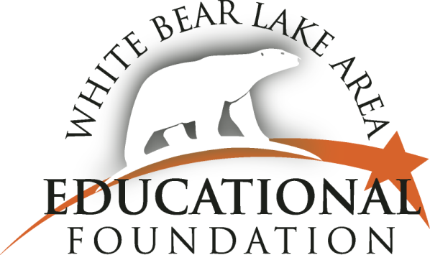

4855 Bloom Avenue, Room 116 | White Bear Lake, MN 55110 | (651) 407-7696 | www.wblaef.org

LYNN MIELKE DISTINGUISHED EDUCATOR AWARD
2024 Nomination Form

Dear White Bear Lake District Staff, Students, Parents and Community Members,

The White Bear Lake Area Educational Foundation is pleased to honor Lynn Mielke, a former White Bear Lake cherished educator. We will again this year grant the Lynn Mielke Distinguished Educator award
to an employee in the White Bear Lake School Community who uses his or her talents to enrich the
lives of others.

This award honors Lynn and her contributions to the White Bear Lake Area Schools and particularly her positive impact on students with special needs. Lynn was a speech/language clinician and special education coordinator. She worked for our District for more than 25 years. Everyone who met Lynn respected her for the concern she showed to each individual. Lynn recognized each employee in the school community and the important role they played in the lives of the students and their families.

This award, given in memory of Lynn and her legacy, acknowledges others who have positively impacted the lives of students and their families.

A nomination form is attached. Please carefully review the details. Nomination forms may be submitted by an individual or a group, with one letter of nomination. Your letter and nomination form are due, by email, on or before Monday, April 8, 2024. This award may be given to anyone who works in the White Bear Lake Area School District.

If you are interested in contributing to this award or to the White Bear Lake Area Educational Foundation for other educational programs, please send your tax deductible donation to the Foundation. Thank you for your support.

Best regards,

WBLAEF Lynn Mielke Distinguished Educator Award Committee

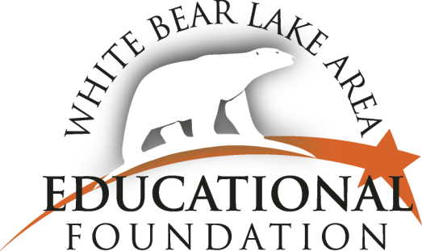

LYNN MIELKE DISTINGUISHED EDUCATOR AWARD
2024 Nomination Form

I/we would like to nominate:

Click here to enter text.

for the Lynn Mielke Distinguished Educator Award.

The nominee serves as a: Click here to enter text. (position)

at: Click here to enter text. (building).

Please provide us with a letter describing the reasons you have nominated this person for the Lynn Mielke Distinguished Educator Award.

Email this completed form and your letter to:
info@wblaef.org

Your letter and nomination form are due on or before April 8, 2024.

Name(s) and contact information of person(s) submitting nomination:

Name Phone
Click here to enter text. Click here to enter text.
Email address
Click here to enter text.

The 2024 Lynn Mielke Distinguished Educator Award recipient
will be announced prior to the end of the school year.

Please contact the White Bear Lake Area Educational Foundation with any questions.
651-407-7696 or info@wblaef.org

Thank you for your support and your nomination.

